Angelo State University
Strategic Planning On-Line (SPOL) - Budget Section Training
Quick-Start Guide
March 2013
http://pba.angelo.edu/spolnet/

The Budget Homepage
The Budget Homepage is a launching pad for the budgeting functions of SPOL. From the Budget Homepage, budget managers can manage their departmental budgets and align them with Angelo State University’s institutional budget policies. Administrators can review and approve budgets with transparency and clarity. The Budget Homepage has several menus indicated below. Users may not see all menu items depending on their security permission and role in the system.

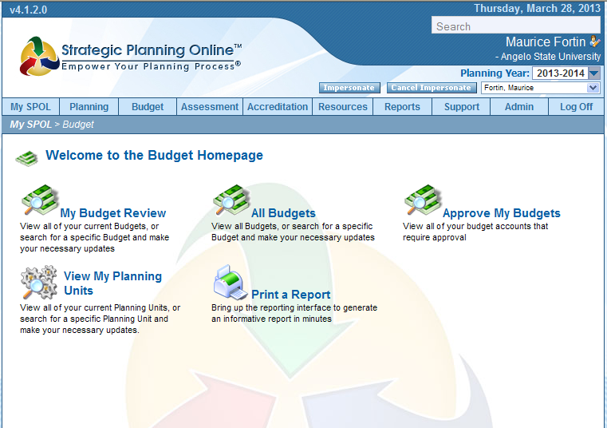
Budget Homepage

Budget Homepage menus

- My Budget Review
Under this menu users can locate and select their budget account by planning unit for review or editing. The budget review is where budget managers develop their operational and enhanced budgets.

- Approve My Budgets
On this page unit managers and budget managers can review summaries of their budgets (and their subordinates’ budgets) and approve or reject the budget en mass. Only system administrators and unit managers with the appropriate security permissions can see this menu item. Some users will not see this menu item.

- View My Planning Units
If you are a member of various planning units, you could view or search for them here.

- Print a Report
This menu item is a quick link to the Reports page.

My Budget Review Page
Click into “My Budget Review” to view the “My Budget Search” page.

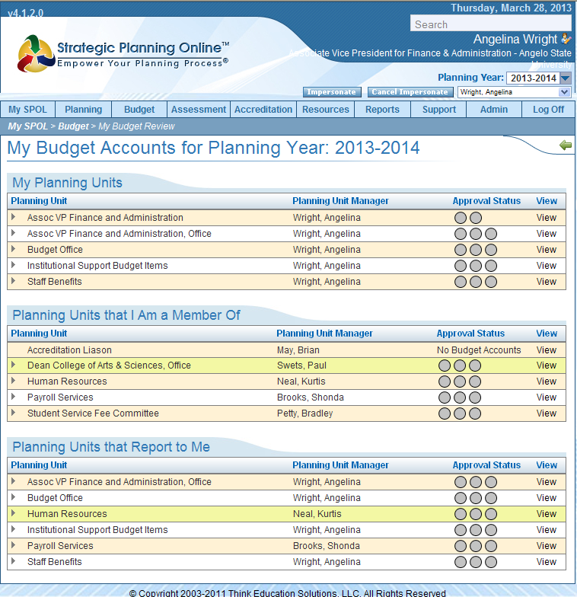
My Budget Search page
My Budget Search page
On this page users can locate and select their budget accounts and planning units for review or editing. The list of planning units is broken down into three main categories (you may or may not see all three depending on your role in the various planning units):

Budget Account Categories

- My Planning Units
This area presents a list of budget accounts by planning unit that the current user is directly responsible for.

- Planning Units that I Am A Member Of
This area presents a list of budget accounts by planning unit that the current user is collaterally responsible for managing as a member of the planning unit, but not the unit manager.

- Planning Units that Report to Me
This area presents a list of budget accounts by planning unit that report directly to the current user, but that the current user is not directly responsible for as the immediate unit manager.

Budget Account Indicator
The budget account indicator is a graphic arrow next to the planning unit indicating that budget account records exist under the associated planning unit. If you do not see a budget account Indicator arrow next to a planning unit, it means that no budget accounts exist under the associated planning unit. If you see a budget account indicator arrow next to a planning unit, click on the planning unit’s row to drop down a list of the budget accounts associated with it:
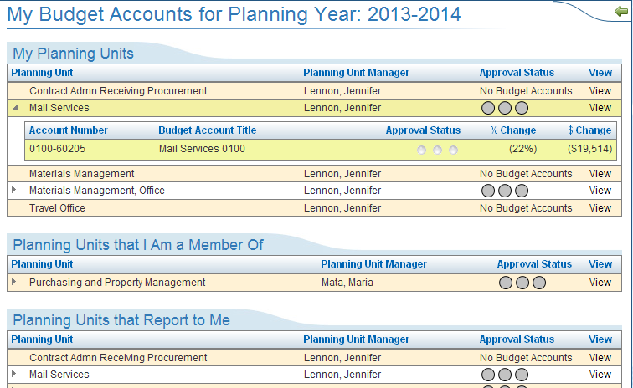
Budget Account Indicator

Once you have located the budget account you wish to edit, double click on the budget account to navigate to the “Budget Detail” page in view mode. From this page you can view or edit the budget account you’ve selected.
Budget Detail Page

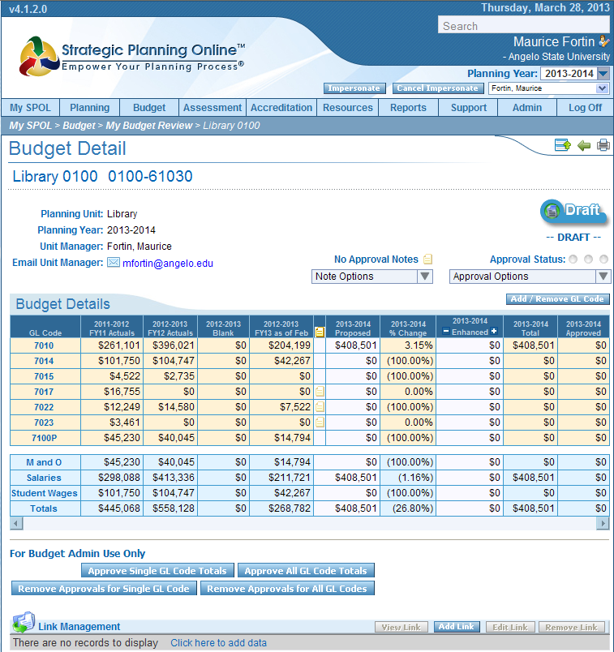
Hovering the curser over a General Ledger code in the first column will show a definition of the code in a pop-up.

The budget account detail page displays a single budget account’s budget requests by General Ledger code (General Ledger codes are accounting codes used to classify expenditures), with detailed and summary information about the budget account. This page allows users to view and edit their budget requests, review their historical spending information, and create new requests for both their operational and enhanced budgets as needed. The budget account detail page is one of the few pages that combines both the view and edit mode in one page.

The Budget Office has pre-loaded all salary data to a specific position number. Grant funds have been included only when salary is part of the grant, so that we can be assured all salaries are accounted for.

Budget Detail Page Areas – A Closer Look
Each area of the budget account details page is responsible for managing different information about the budget account’s budget requests. This page allows users to review and edit their budgets and approve budgets they are responsible for.

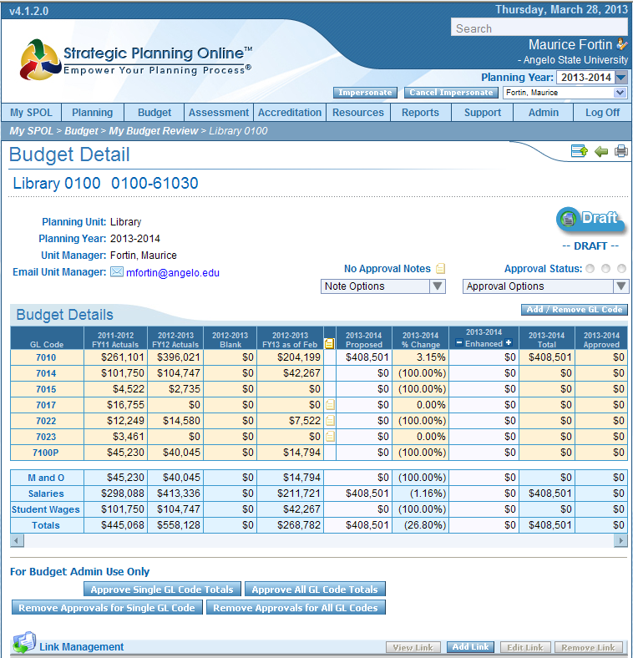
5

1...
2
..

4
3.

Budget Detail page

- Budget Approvals
The Budget Approvals Area allows unit managers to approve their budgets and make it available for the next unit manager to approve.

- Budget Detail
The Budget Details Area displays pertinent information about the budget such as the Account Title, the Unit Manager, the Planning Unit and Account Number.

- Main Budget Grid
The Main Budget Grid displays current budget requests and historical budget information by General Ledger code and category. Users edit and review their budgets in the Main Budget Grid.

- Budget Summary Grid
The Budget Summary Grid displays current requests and historical budget information regrouped by classification. This information helps users manage their budget requests by classification and provides the financial team greater visibility as to how the budget requests are classified overall. New Budget Summary classifications can be created by system administrators.

- Budget Admin Use Only
This area is for the use of budget administrators only. It allows an administrator to approve single line items or the entire budget.

Budget Detail Area also has the following elements:

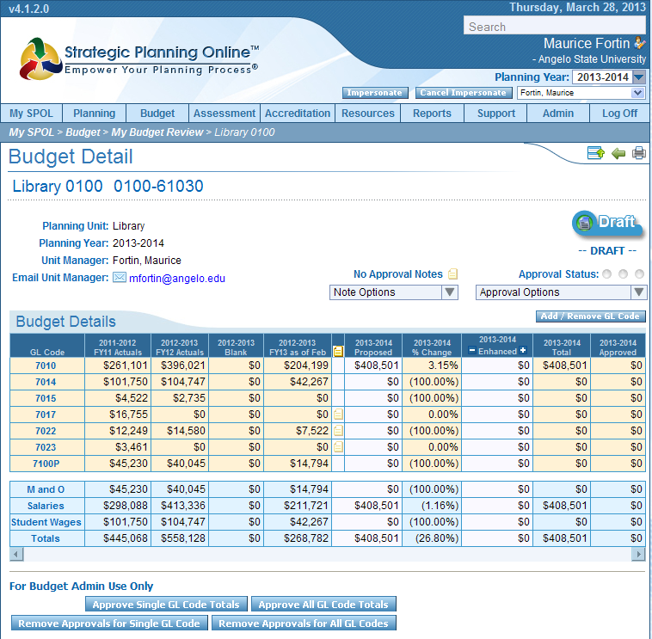
2

1

Budget Details area

- Account Title & Number, Planning Unit , Planning Year, Unit Manager, Unit Manager Email
These fields are read only and cannot be modified from this page.

- Add/Remove GL Code Button
This button allows users to add or remove a new General Ledger Code to their budget. Clicking on this button will bring up the “Add GL Code Pop-Up Window” as seen below:
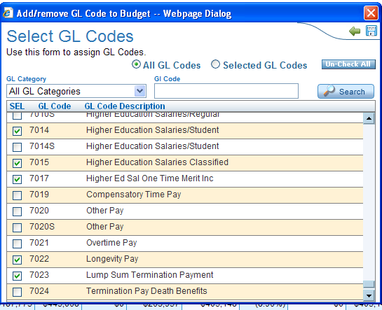
Add GL Code pop-up window

To add a GL code, select it in the drop down list box and click on the “Add” button. To cancel, click on the “back” button. Either action will make the “add GL Code Pop-Up Window” disappear.

Please Note:
- If for any reason you cannot access the “Add GL Code Pop-Up Window” check your security settings for pop-up blocking. Pop-up blockers will disable the “add GL Code Pop-up Window” from Displaying correctly.
- Budget requests associated with the GL Codes being removed are deleted and cannot be recovered once they are deleted.

Main Budget Grid-Columns
The Main Budget Grid displays current budget requests and historical budget information by GL Code and category. In the Main Budget Grid users can manage their budgets and drill down to review individual expenditures. Users can also review the Main Budget Grid to see which requests were approved and the approval amounts after the budget approval process has occurred. Rows on the Main Budget Grid’s columns are fixed system data, detailed below:

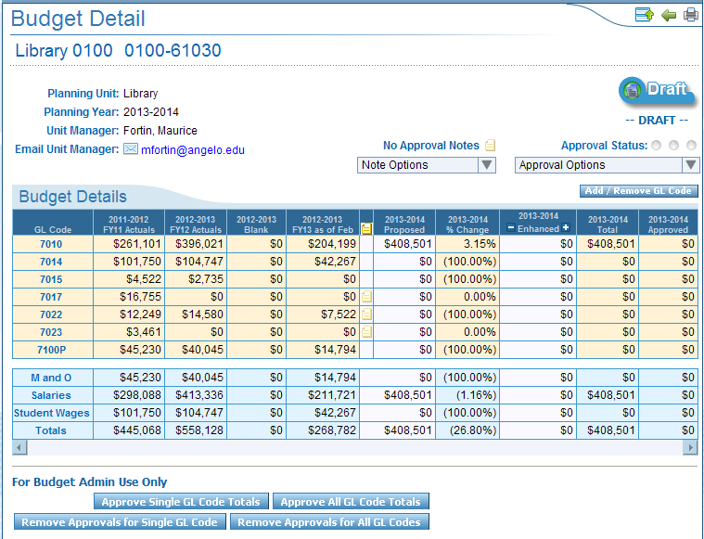
The first line of the headers in the historical data (col 2-5) columns were hard coded in the software and cannot be edited. Please disregard the first line. The second line of the header accurately describes the content of the columns.
Main Budget Grid

The Main Budget Grid has the following column fields:
- GL Code
This column contains the GL codes assigned to this budget account. GL Codes can be added or removed by using the “Add GL Code” and “Remove GL Code” buttons.
- FY11 Actuals(Historical Data)
Captures 2011 fiscal year-end expenditures for historical reference.
- FY12 Actuals(Historical Data)
Captures 2012 fiscal year-end expenditures for historical reference.
- Blank
This column is not being used to house any financial data.

- FY13 as of Feb
Represents the Banner 9/1 budget load, plus or minus any budget adjustments entered, through February 2013.
- Budget Notes
The budget notes column displays a series of small notepad icons. This allows users to enter and review notes about budget requests. To enter, double-click on the note icon to bring up the Budget Notes pop-up window. Enter in your note and click on the save icon.

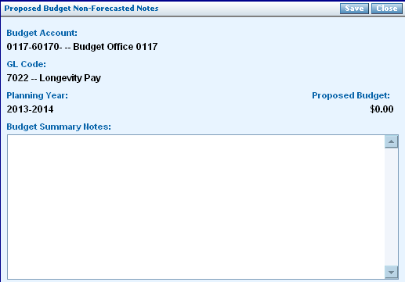
Budget Notes Pop-Up window

- Proposed
This represents the base budget. Requests for budget increases should be entered through an Enhanced Request.
- % Change
A system calculated field that displays the difference between the current year’s Proposed Budget and FY12’s Actuals.
- Enhanced
The Budget Manager enters enhanced budget requests here. This column displays enhanced budget requests totaled by GL Code. Budget requests made with Objectives via a Task Budget Request will automatically be brought forward into this field.
- Total
This is a system calculated field that displays the total of the Proposed Budget Requests and the Enhanced Budget Requests.

- Approved
System calculated field that displays the total of the Approved Budget Requests (both Proposed and Enhanced).

Making entries in the Enhanced Column
It is important to note that enhanced requests must be tied to an existing objective and a task in the Planning module before you can link a budget to it.

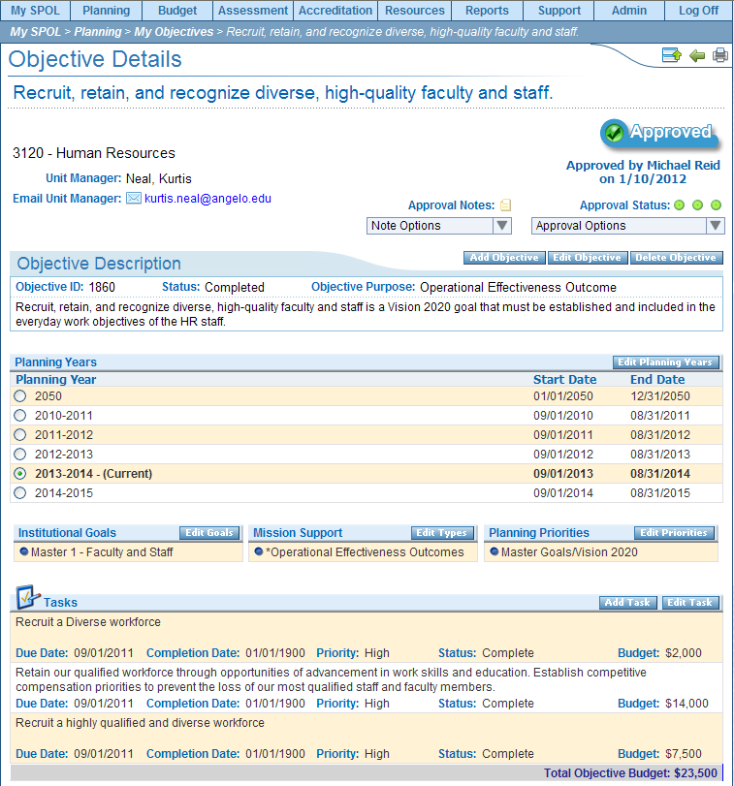
The screen shot above is an example of an objective created through the Planning Module. Tasks, with corresponding budget requests are shown at the bottom of the page. For assistance with creating Objectives and Tasks in the Planning Module, please contact Brandy Hawkins, Office of Accountability.

To add data in the Enhanced Budget Column

Click here to enter data.
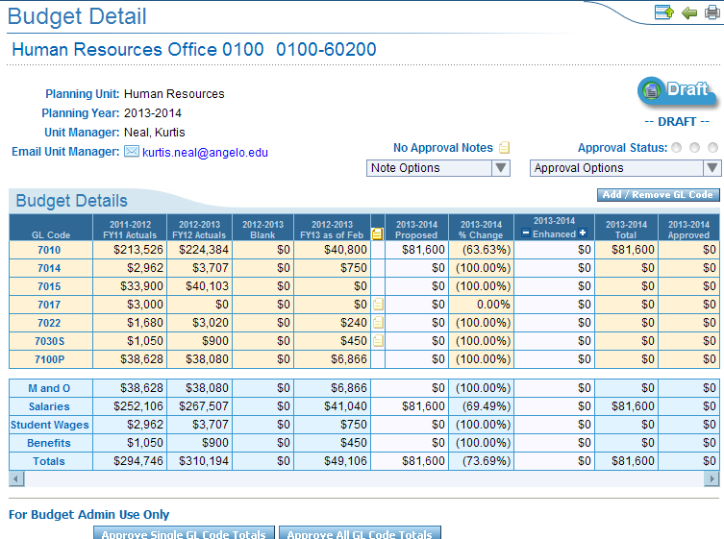
A budget item detail list screen will pop-up.
Choose the year you want to enter data on from the tabs across the top of the form
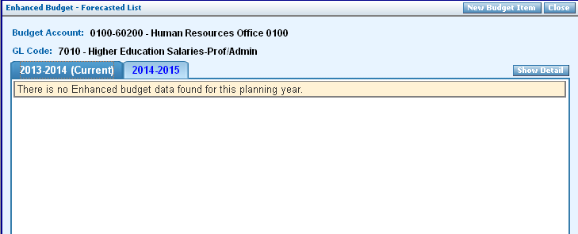
Budget Item Detail List

Then click on the New Budget Item button in the upper right of the form.

The new form will look like this:

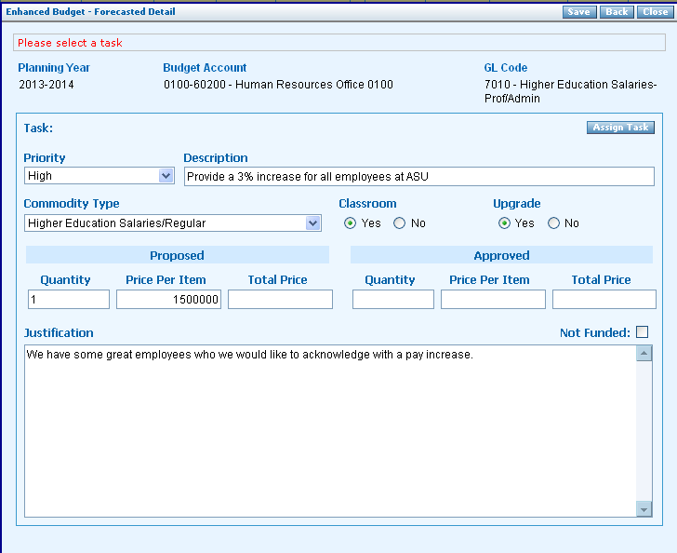

Priority - can be set to high, medium or low using the drop down menu options. Priorities can be set by ASU, so in the information this field and how it is used may vary.

Commodity Type - will have drop down options to choose from to describe the request.

After all fields have been entered click on the Assign Task button in the upper right hand corner.

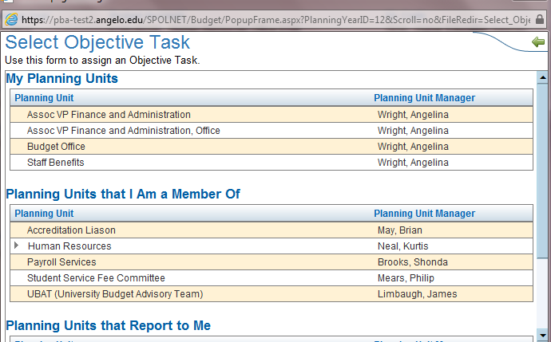
The budget indicator will point to the associated account. Click the budget indicator to open and find the associated Objective. Drill into the Objective the find the task.
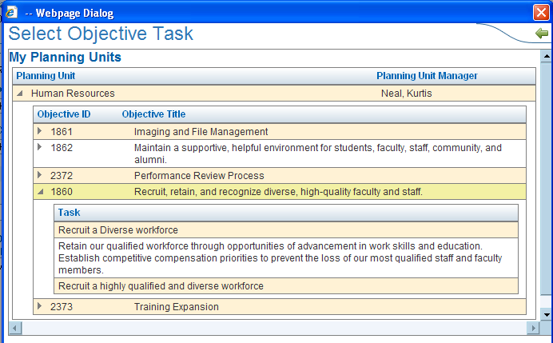
Once you click on the task, the objective will be tied to the enhanced budget request, as shown below.

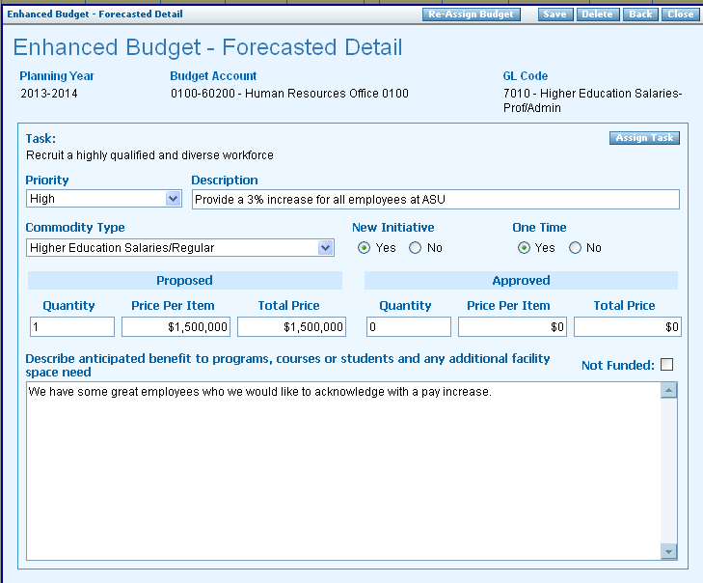
Save button
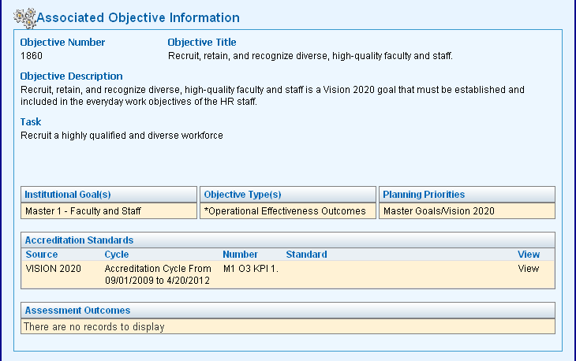

IMPORTANT
Remember to save the data before returning to the main budget detail screen. All data entered on the enhanced request will be lost if not saved.

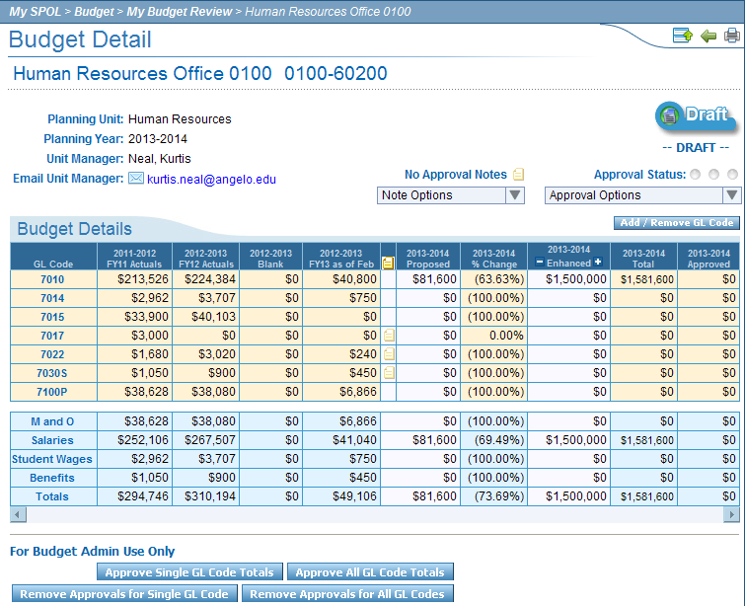

The enhanced request now shows in the appropriate column.

If you need additional assistance with entering, reviewing or approving your budget in SPOL, please contact us in the Budget Office at (325) 942-2517.

